**Demonstration of using Responsive Images**

* Two images are used for this demonstration: Australia map and Book.



Figure 1. Australia map (Left) and Book (Right)

* The above images (Figure 1) are prepared in different width: 320px and 640px for each.
* 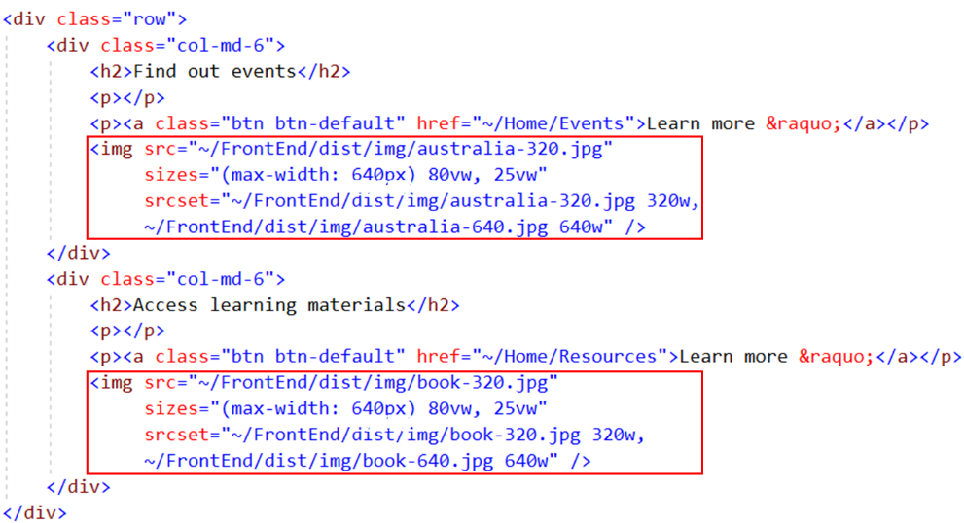To make them responsive to the resolution, the **srcset** attribute was used to load the image. As shown in Figure 2, when the viewport width is greater than 640px, the image will be displayed 25% of the viewport width. If not, it the image will occupy 80% of the view port width.

Figure 2. the srcset attribute was used in the img tag

* When the application is running, the images appear in the Home page. Press F12 and click on the “Toggle device toolbar” (Figure 3).

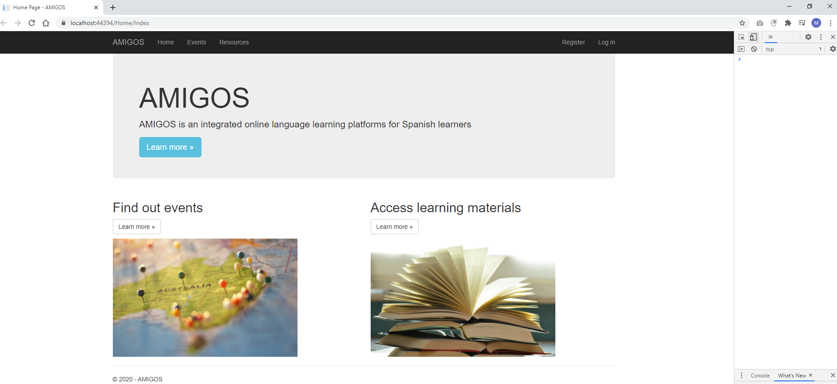

Figure 3. Toggle device toolbar in a red box

* Entering 640 as width displays how these images would look like when the browser has a resolution of 640px.

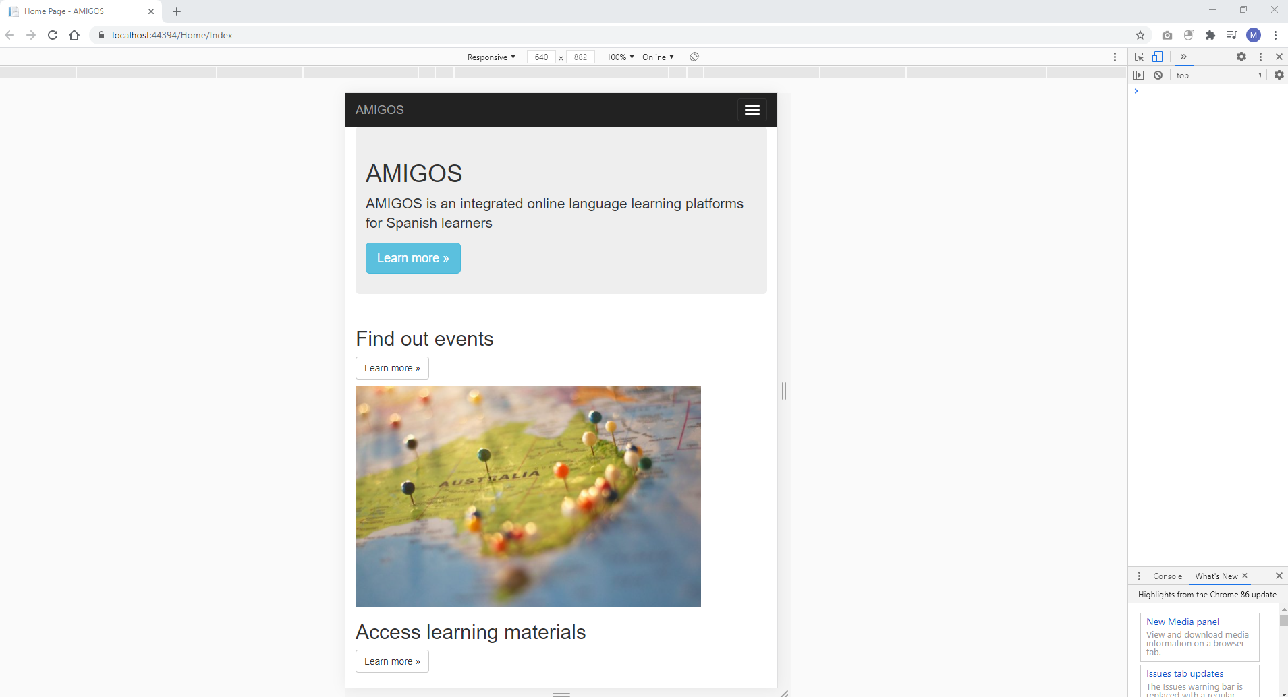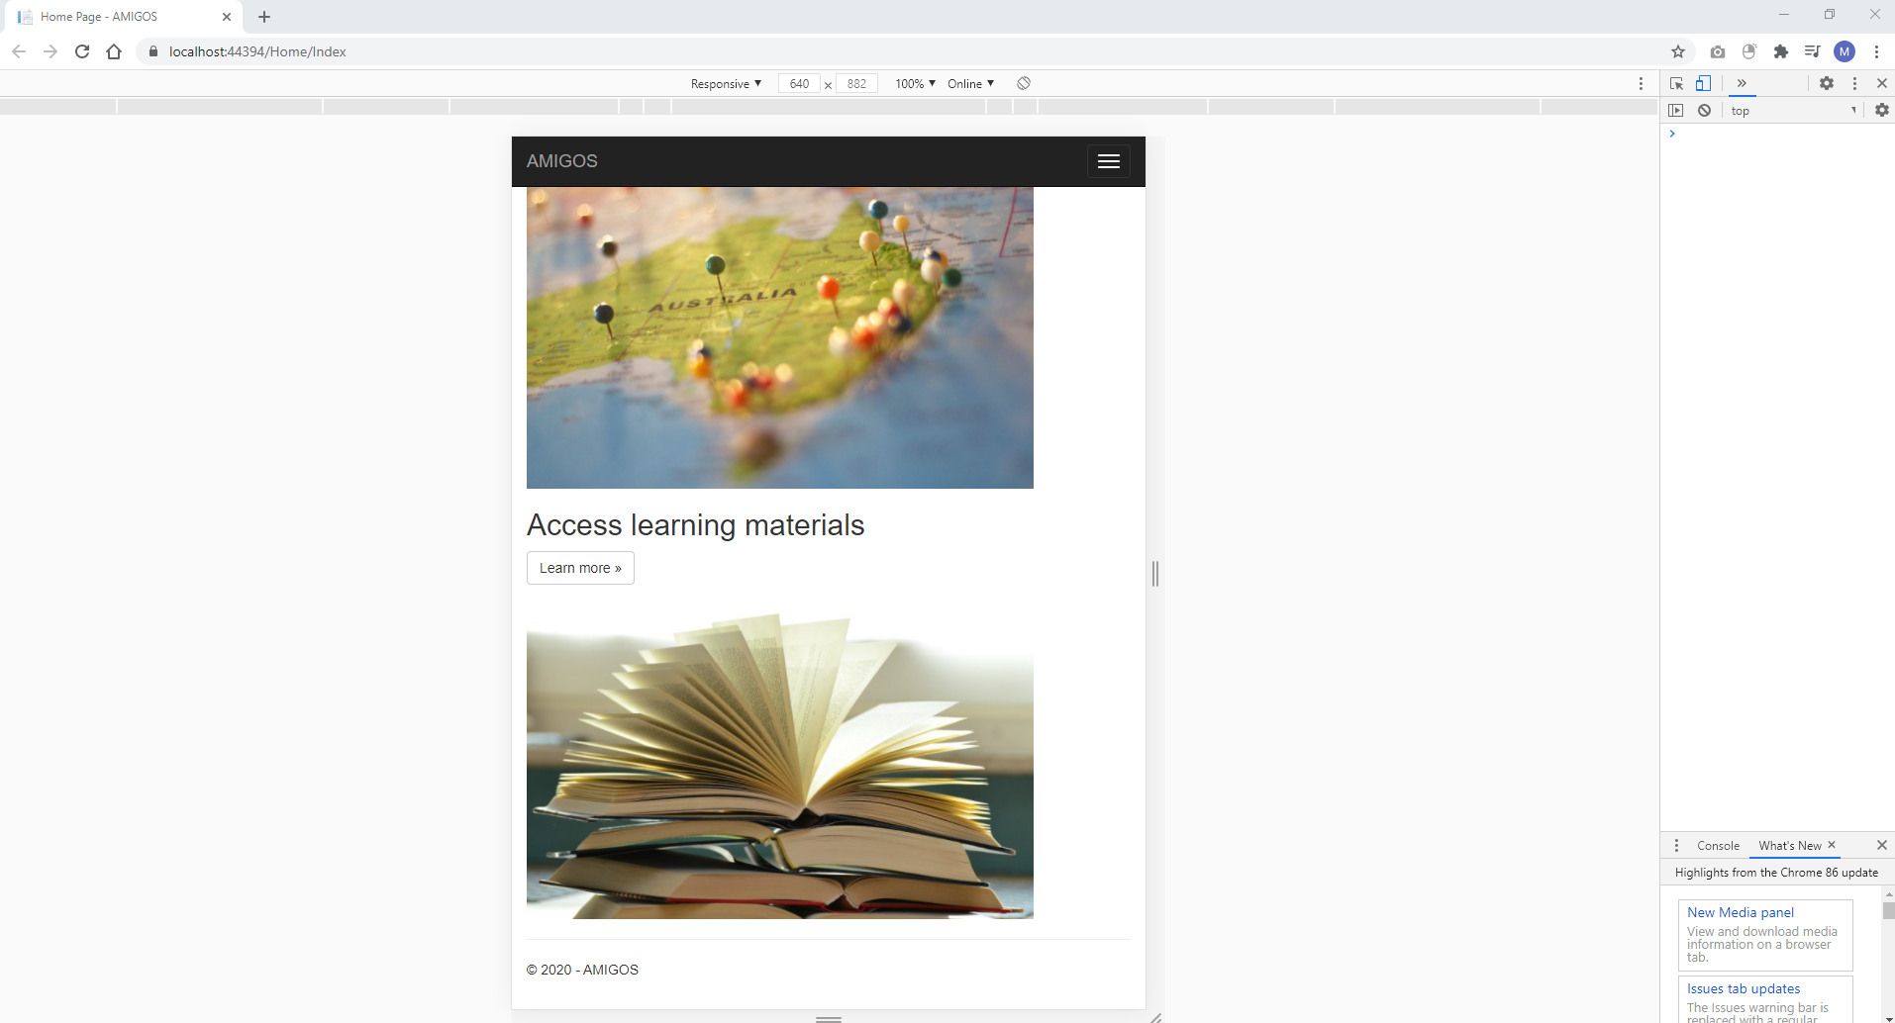

Figure 4. The browser having a resolution of 640px

* Entering 320 as width displays how these images would look like when the browser has a resolution of 320px.

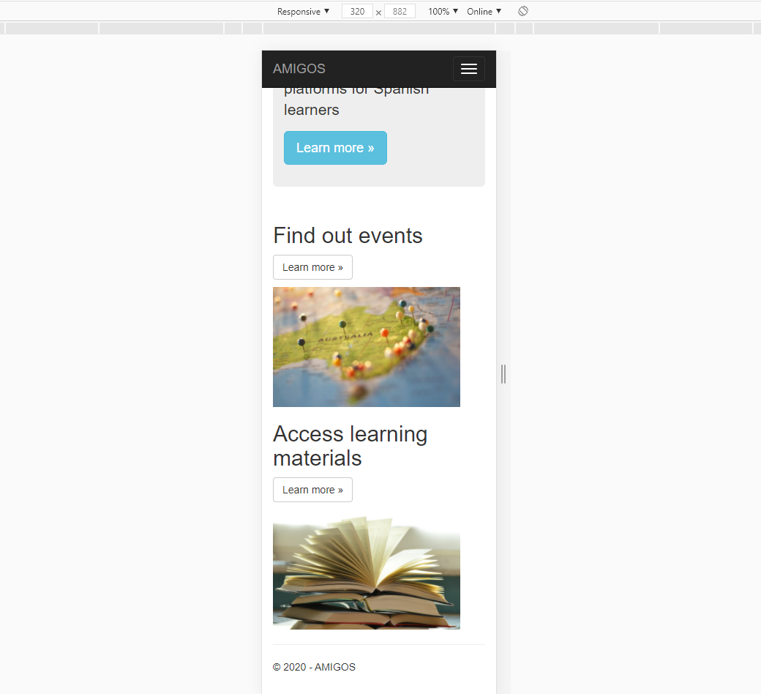

Figure 5. The browser having a resolution of 320px